Device: cuda
GPU: NVIDIA A100-SXM4-40GB
VRAM: 42.4 GB

PBT-V v5.5a Adapter:
Total params: 7,595,610
Module W params: 4,743,180 (Probabilistic)
Module M params: 39 (LSTM)
Beta init: [1.0, 1.0, 1.0] (equal)

==========================================================================================
Creating Enhanced CIFAR-10 Sequences (same as v3)
==========================================================================================
Downloading CIFAR-10...
100%|██████████| 170M/170M [00:07<00:00, 21.4MB/s]
Total: 1550 seq × 8 frames = 12400 frames
Train: 1085 | Val: 232 | Test: 233

preprocessor_config.json: 100%
436/436 [00:00<00:00, 43.9kB/s]
config.json: 100%
548/548 [00:00<00:00, 2.34kB/s]
The image processor of type `BitImageProcessor` is now loaded as a fast processor by default, even if the model checkpoint was saved with a slow processor. This is a breaking change and may produce slightly different outputs. To continue using the slow processor, instantiate this class with `use_fast=False`.
model.safetensors: 100%
346M/346M [00:01<00:00, 906MB/s]
Loading weights: 100%
223/223 [00:00<00:00, 1117.93it/s, Materializing param=layernorm.weight]
==========================================================================================
Pre-computing Hidden States
==========================================================================================

TRAIN...
Train 200/1085 (17s)
Train 400/1085 (33s)
Train 600/1085 (49s)
Train 800/1085 (64s)
Train 1000/1085 (80s)
Train done: 1085 seq in 87s

VAL...
Val 200/232 (16s)
Val done: 232 seq in 18s

TEST...
Test 200/233 (16s)
Test done: 233 seq in 18s

==========================================================================================
Training PBT-V v5.5a (A-E-V-M_LSTM-W_Probabilistic Loop)
KEY: Module W now predicts mu + log_var (Probabilistic)
==========================================================================================
Epoch 0 | Loss 3.739 | W_NLL -2.500 | Train 90.2% | Val 91.6% | β [0.85,0.86,0.84] | σ² 0.2672 | Π_max 2.16 ★ BEST
Epoch 4 | Loss 2.133 | W_NLL -3.240 | Train 92.8% | Val 92.6% | β [1.70,0.93,1.38] | σ² 0.5564 | Π_max 3.39 ★ BEST
Epoch 5 | Loss 0.953 | W_NLL -3.291 | Train 97.2% | Val 96.8% | β [1.90,0.92,1.50] | σ² 0.2981 | Π_max 3.72 ★ BEST
Epoch 8 | Loss 0.639 | W_NLL -3.384 | Train 98.4% | Val 96.8% | β [2.25,0.61,1.44] | σ² 0.2449 | Π_max 4.94 ★ BEST
Epoch 10 | Loss 0.475 | W_NLL -3.411 | Train 98.8% | Val 96.8% | β [2.46,0.29,1.30] | σ² 0.2328 | Π_max 4.84
Epoch 12 | Loss 0.594 | W_NLL -3.428 | Train 99.0% | Val 97.0% | β [2.61,0.10,1.22] | σ² 0.2270 | Π_max 5.56 ★ BEST
Epoch 15 | Loss 0.248 | W_NLL -3.457 | Train 99.5% | Val 96.3% | β [2.61,-0.03,1.19] | σ² 0.2212 | Π_max 4.33
Epoch 20 | Loss 0.258 | W_NLL -3.497 | Train 99.6% | Val 96.4% | β [2.63,-0.15,1.11] | σ² 0.2158 | Π_max 5.56
Epoch 25 | Loss 0.108 | W_NLL -3.533 | Train 99.8% | Val 95.0% | β [2.60,-0.09,1.10] | σ² 0.2086 | Π_max 5.49
Epoch 30 | Loss 0.028 | W_NLL -3.563 | Train 99.9% | Val 96.2% | β [2.51,-0.09,1.09] | σ² 0.2034 | Π_max 5.87
Epoch 35 | Loss 0.024 | W_NLL -3.580 | Train 100.0% | Val 96.6% | β [2.46,-0.09,1.08] | σ² 0.2006 | Π_max 6.05

Best val: 97.0%
Training time: 10032s
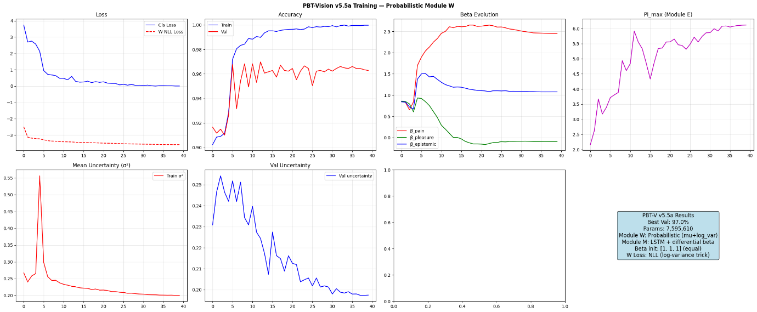
Saved: pbt_vision_v55a.pth

==========================================================================================
Comprehensive Test + Ablation — PBT-V v5.5a
==========================================================================================

Overall: 97.5%

precision recall f1-score support

SAFE 0.9934 0.9759 0.9846 1536
ANOMALY 0.8958 0.9695 0.9312 328

accuracy 0.9748 1864
macro avg 0.9446 0.9727 0.9579 1864
weighted avg 0.9762 0.9748 0.9752 1864

By Type:
context_nature_frog : 99.6% (232 frames)
context_road_frog : 99.2% (256 frames)
drift_safe : 100.0% (264 frames)
gradual_drift : 87.8% (304 frames)
normal_nature : 99.7% (288 frames)
normal_road : 100.0% (272 frames)
sudden_anomaly : 97.6% (248 frames)

Running ablations (Overall Accuracy)...

Configuration Overall
────────────────────────────────────────
Full (A+E+V+M+W) 97.5%
No A (no gating) 90.8%
No W (naive predict) 97.1%
No E (uniform Pi) 97.5%
No M (no memory) 88.8%

==========================================================================================
Context Test: Same Frog, Different Meaning (v5 LSTM)
==========================================================================================

Road+Frog (should be UNSAFE):
Frame 0: UNSAFE=0.000 R=0.000 gate_mean=0.481 V_acc=[0.26, 0.01, 0.00]
Frame 1: UNSAFE=0.000 R=0.928 gate_mean=0.795 V_acc=[0.52, 0.02, 0.00]
Frame 2: UNSAFE=0.000 R=1.815 gate_mean=0.921 V_acc=[0.78, 0.02, 0.00]
Frame 3: UNSAFE=0.000 R=2.734 gate_mean=0.975 V_acc=[1.05, 0.02, 0.03]
Frame 4: UNSAFE=1.000 R=3.717 gate_mean=0.993 V_acc=[1.28, 0.01, -0.01]
Frame 5: UNSAFE=1.000 R=4.398 gate_mean=0.997 V_acc=[1.35, -0.02, -0.08]
Frame 6: UNSAFE=1.000 R=4.466 gate_mean=0.997 V_acc=[1.32, -0.02, -0.20]
Frame 7: UNSAFE=1.000 R=4.082 gate_mean=0.996 V_acc=[1.56, 0.00, -0.16]

Nature+Frog (should be SAFE):
Frame 0: UNSAFE=0.000 R=0.000 gate_mean=0.481 V_acc=[0.01, -0.03, -0.10]
Frame 1: UNSAFE=0.000 R=-0.236 gate_mean=0.388 V_acc=[0.15, -0.01, -0.13]
Frame 2: UNSAFE=0.000 R=0.223 gate_mean=0.572 V_acc=[-0.31, -0.06, -0.34]
Frame 3: UNSAFE=0.000 R=-1.940 gate_mean=0.081 V_acc=[-0.19, -0.02, -0.34]
Frame 4: UNSAFE=0.000 R=-1.475 gate_mean=0.118 V_acc=[-0.03, -0.01, -0.33]
Frame 5: UNSAFE=0.000 R=-0.890 gate_mean=0.199 V_acc=[-0.04, -0.03, -0.38]
Frame 6: UNSAFE=0.000 R=-1.065 gate_mean=0.168 V_acc=[0.12, -0.01, -0.35]
Frame 7: UNSAFE=0.000 R=-0.437 gate_mean=0.318 V_acc=[0.31, -0.00, -0.33]

==========================================================================================
Module Analysis — v5.5a Probabilistic W
==========================================================================================

Module E Precision Pi_l:
Layer 0 (Perception): Pi = 5.5553
Layer 1 (Perception): Pi = 0.9735
Layer 2 (Perception): Pi = 1.2550
Layer 3 (Perception): Pi = 4.1460
Layer 4 (Evaluation): Pi = 3.2535
Layer 5 (Evaluation): Pi = 1.7233
Layer 6 (Evaluation): Pi = 2.9774
Layer 7 (Evaluation): Pi = 2.6702
Layer 8 (Decision ): Pi = 2.7843
Layer 9 (Decision ): Pi = 0.7440
Layer 10 (Decision ): Pi = 0.6748
Layer 11 (Decision ): Pi = 0.8181

Module M v5 — LSTM Gates:
Beta (differential forget bias):
beta_pain = 2.6096
beta_pleasure = 0.0993
beta_epistemic= 1.2178
Effective forget bias (b_f + beta):
pain = 4.2193 → sigmoid = 0.9855
pleasure = -0.8015 → sigmoid = 0.3097
epistemic= 1.4356 → sigmoid = 0.8078

★ Module W — Uncertainty Analysis (sigma^2 per layer)

Layer σ²_safe σ²_unsafe Δσ² MSE_safe MSE_unsafe Δ_MSE
─────────────────────────────────────────────────────────────────────────────────────
Layer 0 (Perception) 0.0000 0.0000 +0.0000 0.0000 0.0000 +0.0000
Layer 1 (Perception) 0.0000 0.0001 +0.0000 0.0000 0.0001 +0.0000
Layer 2 (Perception) 0.0000 0.0000 +0.0000 0.0000 0.0001 +0.0000
Layer 3 (Perception) 0.0002 0.0002 +0.0000 0.0001 0.0001 +0.0000
Layer 4 (Evaluation) 0.0003 0.0004 +0.0000 0.0003 0.0004 +0.0001
Layer 5 (Evaluation) 0.0006 0.0007 +0.0000 0.0007 0.0008 +0.0002
Layer 6 (Evaluation) 0.0047 0.0054 +0.0007 0.0039 0.0050 +0.0012
Layer 7 (Evaluation) 0.0070 0.0076 +0.0006 0.0059 0.0074 +0.0015
Layer 8 (Decision ) 0.0226 0.0242 +0.0016 0.0215 0.0271 +0.0056
Layer 9 (Decision ) 0.0665 0.0739 +0.0074 0.0581 0.0815 +0.0234
Layer 10 (Decision ) 0.3530 0.3875 +0.0344 0.3092 0.4620 +0.1527
Layer 11 (Decision ) 2.4055 2.0103 -0.3952 2.0768 2.4683 +0.3915

★ V_epistemic with uncertainty modulation:
V_epistemic (safe): -0.1461 ± 0.2961
V_epistemic (unsafe): -0.2464 ± 0.1828

★ Context Test — Uncertainty Divergence

Road+Frog (UNSAFE):
Frame UNSAFE σ²_mean V_epistemic
────────────────────────────────────────
0 0.0000 0.1933 +0.0074
1 0.0000 0.1939 +0.0058
2 0.0000 0.1933 +0.0109
3 0.0000 0.1795 +0.0276
4 0.9935 0.1889 -0.0088
5 1.0000 0.2394 -0.1041
6 0.9375 0.2262 -0.1767
7 0.9862 0.2274 -0.2145

Nature+Frog (SAFE):
Frame UNSAFE σ²_mean V_epistemic
────────────────────────────────────────
0 0.0000 0.3175 -0.1175
1 0.0000 0.3135 -0.1974
2 0.0000 0.3228 -0.2721
3 0.0000 0.3075 -0.3048
4 0.0000 0.3423 -0.3914
5 0.0002 0.2294 -0.3867
6 0.0002 0.2259 -0.3823
7 0.0355 0.2258 -0.3819
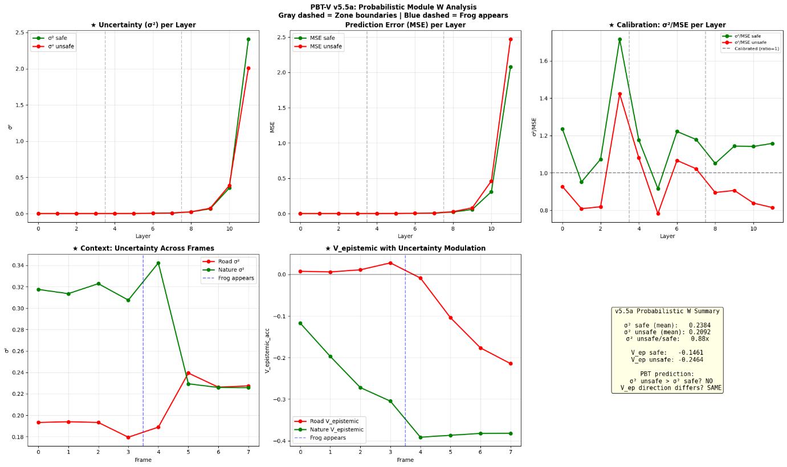
==========================================================================================
v5.5a Analysis Complete!
==========================================================================================
Download complete!

